**CONSERVATORS OF THE RIVER CAM**

*Navigation authority for the River Cam, between Cambridge and Bottisham Lock*

***River guidance***

***Stay safe and respect the river and its users.***

If you collide with another vessel – STOP, TALK TO EACH OTHER AND EXCHANGE DETAILS

Communicate peacefully, don’t be abusive.

Take your rubbish home, no fly tipping or leaving fishing line and hooks.

keep noise levels to a minimum – Consider your neighbours and river users at all times.

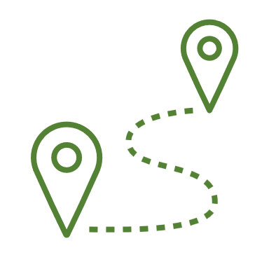Use the towpath lawfully and with consideration for all users.

Do not pollute the river. Report any pollution to EA hotline 0800 80 70 60.

Report all river obstructions to the Conservancy website or call 01223 863785

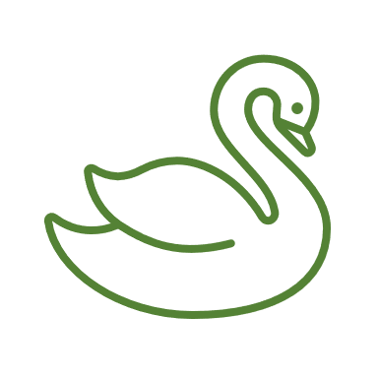Respect the wildlife. Do not interfere or disturb the wildlife or any protected species.

DON’T drink alcohol or drugs whilst operating a vessel.



**Conservators of the River Cam**

**Clayhithe Office, Clayhithe Road, Horningsea, Cambridge, CB25 9JB**

**Office 01223 863785**

**Website www.camconservators.org.uk**